 | 
 | 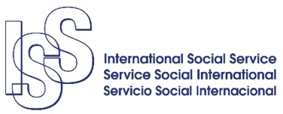 | 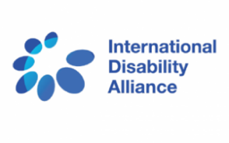

Concept Note

Parent and family leadership in preventing institutionalization of children with disabilities: promising practices from countries in transition
People with disabilities have the right to live in the community, according to Article 19 of the UN Convention on the Rights of Persons with Disabilities. However, more than a decade after the adoption of the CRPD by the UN and nearly global ratification, children with disabilities continue to be placed in institutions in every region of the world. Worse still, low-middle income countries that have never had systems of institutionalization have started to build them.
In 2017, the CRPD Committee adopted general comment No. 5 on Article 19 on living independently and being included in the community, which clearly stated the obligation of States Parties to adopt a plan for deinstitutionalization, including the closure of current institutions and not to build new ones. Yet, without quality community services and support for parents, institutions are seen to provide better care than children with disabilities would receive at home.
As countries seek to uphold their obligations to the CRPD and approach care reform for children with disabilities, the end of institutionalization will only be successful if reforms include preventative measures and family strengthening efforts. True systemic change will only occur when the causes of institutionalization are addressed, as well as the closure of existing institutions. Examples of good practices in these areas do exist and they are often led by parents of children with disabilities. As governments develop legal and policy frameworks and social services to keep children with disabilities with their families, parents are engaged in peer support and advocacy.
By drawing on the experiences of parents, advocates, NGOs, and public officials, this side event will invite discussion on how through strengthening families and tools for prevention, societies can reduce the number of children being institutionalized. Panelists and the audience will seek to address the following questions:
- How can parents and families be involved in peer support and advocacy to prevent institutionalization? How has parent leadership been effective?
- How do we improve communication and collaboration through CSOs, ODPs, parent groups, government agencies, and service providers to improve prevention efforts, improve referral pathways for services, and remove the perceived need for institutional care?
- What steps can governments take to ensure comprehensive care reform (gatekeeping, inclusive services, etc.)?
- How do other intersecting identities of gender, race, and region impact individual experiences of caring for children with disabilities?
- What are examples promising practices and successful collaborations from NGOs, families, governments, and other stakeholders?
- What can we learn from the experiences of parents of children with disabilities around the world and what needs to change?
Join a panel of experts from the Republic of Moldova, South Africa, Burkina Faso, Vietnam, and the United States as we explore these questions and experiences around efforts to empower parents and keep children with disabilities with their families. Keystone Human Services works globally to ensure that all people are included, valued members of their communities. Keystone brings together a group of panelists that have extensive expertise and experience, both professional and personal, in supporting families around the world. They bring examples of challenges and successes in building inclusive societies which parents are empowered and children with disabilities can reach their potential.
This side event is co-hosted by Keystone Human Services, International Social Service, SPOON, Shonaquip Social Enterprises, and Inclusion International, with co-sponsorship from the International Disability Alliance.

Moderator:
- Genevieve Fitzgibbon, Deputy Director, Keystone Human Services International
Opening and Closing Remarks:
- Sue Swenson, President, Inclusion International

Panelists:
- Mme Rosalie Ouedraogo, Local parent/advocate, International Social Service, Burkina Faso
- Shona McDonald, Founder and Executive Director, Shonaquip Social Enterprises, South Africa
- Marin Andronache, Self-advocate, Republic of Moldova
- Mishelle Rudzinski, Founder and Executive Director, SPOON, USA
- Ms. Nguyet Trinhthi, Ministry of Labour and Social Affairs, Republic of Vietnam

