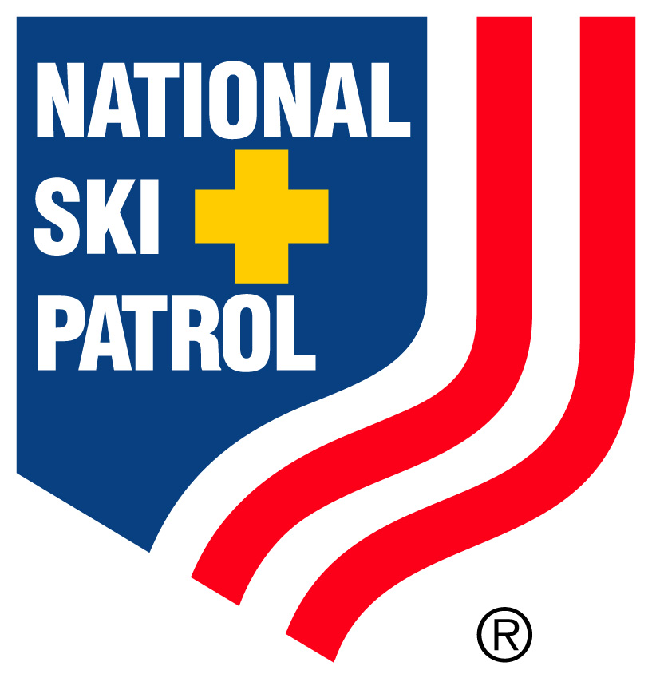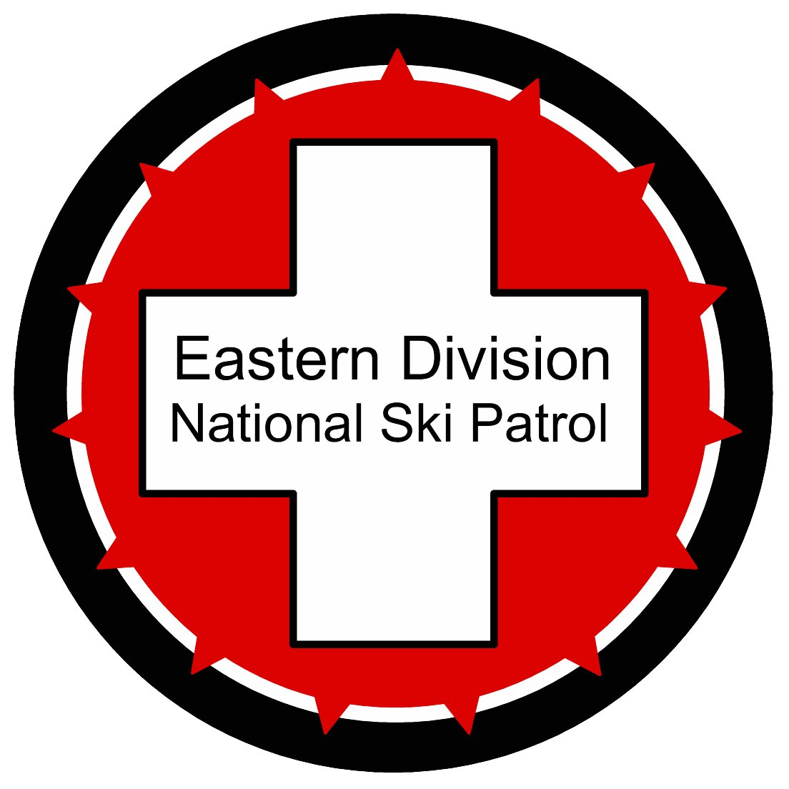
Eastern Division Patrollers School
McCauley Mountain

McCauley Mtn. in Old Forge, New York is pleased to host the Eastern Division Patroller School, February 10th and 11th 2018, overlooking the Fulton Chain of Lakes in the scenic Adirondacks

Accommodations: Please make your reservation before January 26, 2017
The Adirondack Lodge. Please book your reservations under the National Ski Patrol. We have received a room rate of $107.10. The contact number is (315) 369-6836.

Waters Edge Inn. Please book your reservations under the National Ski Patrol. We have received a room rate of $155.00. The contact number is (315) 369-2484.

VanAuken’s Inne. The contact number is (315) 369-3033

Old Forge Camping Resort. Please book your reservation under the National Ski Patrol. Log Cabins $75 sleep 2, Cottages $173 sleep 6. The contact number is (315) 369-6011

Registration:
Please complete the registration form, mailed Jon Wilson, AND register at the NSP website for your respective courses. Login to the NSP and register for the course numbers listed below.
The Patrollers School and Womens Clinic participants will receive a 3-3 ½ hour ski lesson from a PSIA Level III instructor. Our intentions are to implement three different skill levels to accommodate skiers and riders. Please be specific with your skill set – You will have a much more enjoyable day working in your comfort zone.

Patroller School
Snowsport Enhancement Seminar – E227180001
Toboggan Enhancement Seminar – E227180002

Womens Clinic
Snowsport Enhancement Seminar – E227180003
Toboggan Enhancement Seminar – E227180004

Outdoor Emergency Transportation – Senior Trainer Clinic/Evaluation
Instructor Continuing Education Clinic OET – E227180005
Snowsport Trainers Workshop – E227180006
Toboggan Trainers Workshop – E227180007

Certified Pretest
Toboggan Enhancement Seminar – E227180008

Toboggans:
McCauley Mountain is a small ski hill in the Adirondack Mountains. We are not equipped to handle an additional 90 ski patrollers utilizing our equipment. To make certain each team has a toboggan to accomplish their objectives, we ask that every three patrollers bring a fully operational tuned toboggan, tail rope and carrier with them. The goal is 20 additional toboggans.

We will be utilizing the T-bar lift for the majority of the toboggan transport uphill, so please confirm your front crossover rope is in good order. We will provide a demo for those not familiar with T-bar loading. Please arrive early and transport the toboggans to the yurt next to the ski patrol building. We will have a sign in sheet to track toboggans. Yes, they will be safe there.
Fees:
There is a $85.00 per person fee for those attending the Patroller School and Womens clinic. Please mail check to Jon Wilson, 218 Loomis Street, North Granby, CT 06060. There is a late fee penalty for those registering after January 27th. The charge is $25.00
Lunch:
McCauley Mtn. Ski Patrol will have soups and sandwiches available to all patrollers for lunch. We would ask for a $10 donation per person please. Breakfast options will be available at the hill in the morning. Coffee and water will be available through out the day at the yurt.
Jackets:
Please wear civilian jackets for the Patroller School. Staff and Steering jackets are acceptable. We will be issuing lift tickets each day. Please feel free to bring a backpack with snacks, change of gloves, etc. We will provide storage locations on the hill for each team.
Schedule:
There will be four events running simultaneously. The Patroller School with PSIA Level III instructors, a Womens Clinic at the Patrollers School, Outdoor Emergency Transportation (OET) Senior Trainer Clinic/Evaluation and Certified Pretest.
Friday February 9th 5:15 Walk in the Parade, assemble at High School/Post Office.
Saturday February 10th 7:00 boot up, sign in, and safety briefing
8:00 -11:30 First rotation
11:30 – 12:00 Lunch at Yurt
12:00 – 3:45 Second rotation
4:10 Final Sweep
4:30 – Wine and cheese hosted by McCauley Mtn. Ski Patrol – Please bring a beverage and or snack to share.
6:30 Dinner at the ski hill with live music and fireworks.
Sunday February 11th 7:30 boot up, sign in, and safety briefing
8:00 – 12:00 Third rotation
12:00 Lunch at Yurt
1:00 Review, Surveys and Feedback, free ski.
4:10 Final Sweep
Please contact: Jon Wilson jon@deliverypath.com 315-723-0929
Directions:
McCauley Mountain is located at 300 McCauley Road, Old Forge, NY 13420. NYS thruway to exit 31(Utica) to Route 12 north to Route 28 north. Look for the school on the right and follow signs to ski hill. It is about an hour and fifteen-minute drive from Exit 31. www.McCauleyny.com

