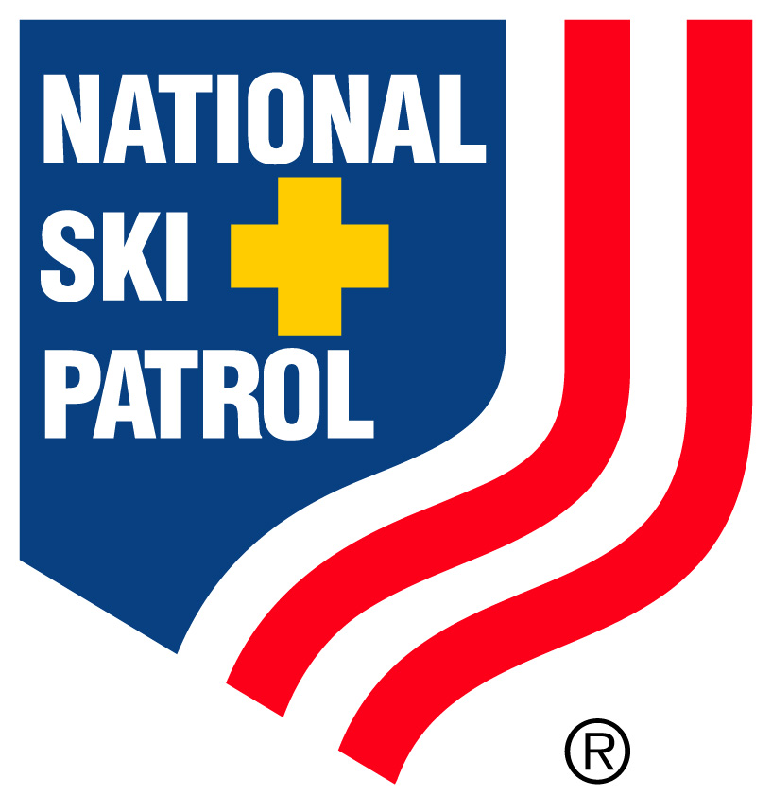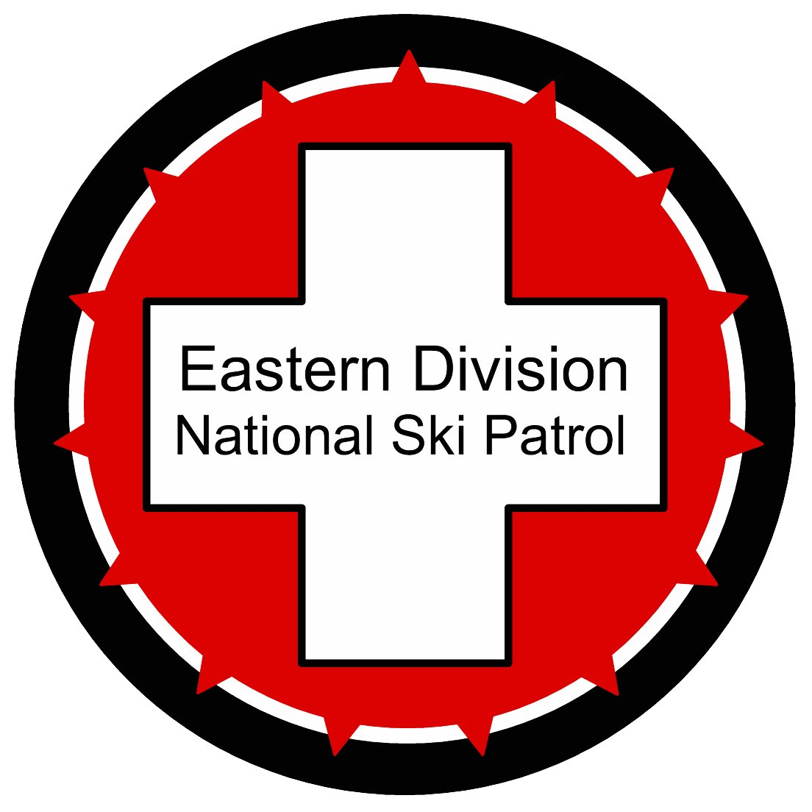
Eastern Division Patrollers School
McCauley Mountain Registration Form
Feb. 10-11, 2018

Name: Patrol Name/ID #:

Address: E-Mail:

City: State: Zip Code: Ph:

Patroller School  Registration Fee: $85.00  (Please Check Two Choices)  Toboggan Enhancement  Snowsport Enhancement  Senior Level Training  Women’s Program | Senior OET T/E Clinic / Evaluation  Senior S&T T/E Initial Certification  Senior S&T T/E Re-certification  Senior T/E Informational Clinic / Witness  Certified Pretest / Re-Cert  Pretest Re-Cert

Registration Deadline: January 26, 2018

Patroller School Teams:
In order to balance the groups by experience and ability level, please answer the following questions:

I have been a patroller for: years at_____________ mountain.
I am a: Alpine Skier Telemark Skier Snowboarder
I can comfortably running toboggans on any snow conditions Y N
I am a competent skier on all senior level terrain including moguls Y N
I am more comfortable on intermediate to expert level terrain Y N
I have operated rescue toboggans for: years, on terrain.
Will you bring a Toboggan with you? Y N

Senior OET T/E Clinic / Evaluation Teams:
Initial Certification – Mentoring completed where? Y N
Re-Certification - # of years as a TE? Y N
Will you bring a Toboggan with you? Y N

********** Civilian jackets only No Crosses – Staff and Steering jackets ok **********

********** Registration after January 27th, 2018 additional $25.00 fee**********

Please Complete and Return Registration Form to:
McCauley Mountain Jon Wilson jon@deliverypath.com 315-723-0929
Jon Wilson – 218 Loomis Street, North Granby, CT 06060

