Master title (Concept note / Agenda)
1 July 2026
Conference Room 8, United Nations Headquarters, New York

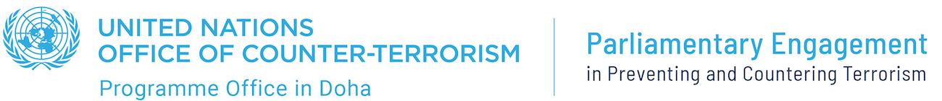


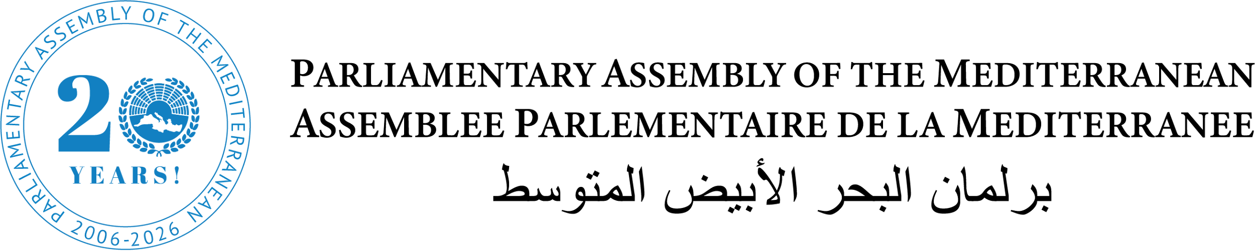

Global Terrorism and AI - Technological Sovereignty and Regulatory Frameworks
The Role Of Parliaments in Applying and Adapting Existing Frameworks For Effective Countering Actions

Organized by the Parliamentary Assembly of the Mediterranean (PAM), with the support of its Centre for Global Studies, in partnership with the Permanent Missions of the Republic of Cyprus and Italy, the UN Security Council Counter-Terrorism Committee Executive Directorate (CTED), the UNOCT Global Programme on Parliamentary Engagement in Preventing and Countering Terrorism, and UNOCT/UNCCT Cybersecurity Unit

Conference Room 8, UNHQ, New York, from 13.00 to 14.30

CONCEPT NOTE

On On 6 December 2024, PAM was elected for the first time to the Presidency of the Coordination Mechanism for Parliamentary Assemblies on Counter-Terrorism, to whose terms of reference PAM had actively contributed. In November 2025, PAM was re-elected for a second term.

PAM's mandate as President reflects a strengthened commitment to reinforcing parliamentary engagement within the United Nations counter-terrorism framework and to consolidating the role of legislatures in responding to evolving security threats. The Assembly is committed to enhancing the effectiveness and inclusiveness of the two pillars of the Mechanism: the strategically important "policy dialogue" and "operational coordination", the latter consisting of technical networking among participating Secretariats and the United Nations.
Throughout its tenure, PAM has given particular attention to the malicious use of artificial intelligence (AI) and emerging technologies by terrorist and criminal groups. PAM, with the support of its Centre for Global Studies (PAM/CGS) and the United Nations Security Council Counter-Terrorism Committee Executive Directorate (CTED), prepared several comprehensive reports, which were also presented at the United Nations, including: The Malicious Use of AI and Emerging Technologies by Terrorist and Criminal Groups: Impact on Security, Legislation, and Governance, published in November 2024, and Spyware Misuse: Legislative, Governance, and Judicial Considerations, Historical Evolution, and Technical Insights, published in December 2025.

PAM, in collaboration with PAM/CGS, is currently working on two new dedicated research projects: The Evolution of Cryptocurrency and Its Implications for Governance, Financial Stability, Security, and Technological Innovation and Artificial Intelligence and Bioterrorism: Emerging Threats, Global Governance, and Policy Responses.

Complementing its research and policy initiatives, PAM championed the first-of-its-kind Parliamentary Training Course on "Legislative and Policy Measures to Prevent and Counter the Use of Artificial Intelligence and New Technologies for Terrorism and Violent Extremism Purposes", held on 4–5 November 2025. The event was jointly organized with the United Nations Office of Counter-Terrorism (UNOCT) Global Programme on Parliamentary Engagement in Preventing and Countering Terrorism, in cooperation with the UNOCT/UNCCT Global Programme on Cybersecurity and New Technologies, with the support of the Shura Council of the State of Qatar and kindly hosted by the Senate of the Hashemite Kingdom of Jordan.

The training gathered 50 participants from among the delegations of PAM Member Parliaments, as well as experts from the United Nations and other international organizations. Throughout two days of substantive discussions, delegates, experts, and UN officials examined key legislative and policy measures to address the misuse of emerging technologies, including AI, by terrorist and violent extremist groups. The sessions explored national responses, human rights considerations, and the development of effective oversight and accountability mechanisms to ensure that counter-terrorism measures remain consistent with international standards.

Against this backdrop, steps taken by national parliaments, international parliamentary assemblies, and parliamentary institutions worldwide to address the misuse of AI and emerging technologies must be operationally aligned with the frameworks adopted through the implementation of existing international instruments and conventions, anchored in the pillars of the United Nations Global Counter-Terrorism Strategy, in compliance with relevant Security Council resolutions on counter-terrorism, and grounded in existing good practices, the rule of law, and human rights.

Strategic, legal, and policy efforts must take into account the rapidly evolving use of new technologies for terrorist purposes and the corresponding threats posed by terrorists to international peace and security. Global cooperation, enhanced integration and interoperability among different approaches, and the sharing of information and good practices are necessary to establish effective guidance without sacrificing innovation.

Objectives of the side event

The side event aims to highlight the crucial role of national parliaments and international parliamentary assemblies in countering terrorism in an era of unprecedented technological evolution. Such cooperation is situated within the broader framework of multilateral, multi-stakeholder, and multi-level governance, as well as comprehensive strategies grounded in respect for human rights and international law.

The side event will examine how diverging approaches to technological sovereignty, together with fragmented legal and policy frameworks, may impede strategic goals and outcomes aimed at strengthening regional and global instruments for countering terrorist narratives and activities, both online and offline.

The side event will also seek to deliver a clear and decisive message: as the Secretary-General of the United Nations has repeatedly stressed, only effective multilateral governance can ensure that technologies are used for the collective benefit of humanity.

Expected outcome of the side event

- Present the work of PAM, PAM/CGS, and Parliamentary Assemblies, within the framework of the UN Coordination Mechanism for Parliamentary Assembly on Counter-Terrorism, to counter the malicious use of AI and emerging technologies.

- Analyze existing legal instruments and frameworks to regulate AI and emerging technologies, in order to assess the level of effectiveness and adaptation required to ensure that the national Parliament provides law-enforcement and judges with new and flexible instruments to mitigate and prosecute terrorism threats.

- Identify a robust parliamentary contribution to the revision and updating of the UN Global Counter-Terrorism Strategy, as well as to the ongoing debates within the European Union on AI challenges and threats by terrorist organizations.

- Provide UN/PAM Member States with a set of recommendations for the promotion and adaptation of national and regional frameworks to counter terrorism in a coordinated and effective manner.

AGENDA

OPENING SESSION  1:00 pm – 1:30 pm | - H.E. Ms. Maria Michail, Permanent Representative of the Republic of Cyprus to the UN in New York  - H.E. Mr. Giorgio Marrapodi, Permanent Representative of Italy to the UN in New York  - Ms. Natalia Gherman, Assistant Secretary-General (ASG) and Executive Director of the Counter-Terrorism Committee Executive Directorate (CTED)  - Mr. Mauro Miedico, Director, United Nations Counter-Terrorism Centre, United Nations Office on Counter Terrorism (UNOCT-UNCCT)  - Hon. Rita Superman (Cyprus), PAM Rapporteur on Counter-Terrorism, and Chair of the Policy Dialogue of the UN Coordination Mechanism for Parliamentary Assemblies on Counter-Terrorism
DISCUSSION  1:30 pm – 2:30 pm | Moderator: Ms. Jennifer Bramlette, Legal Officer/ICT Coordinator, CTED  - Hon. Pedro Roque (Portugal), PAM Vice-President  - Mr. Adam Hadley, Founder and Executive Director of Tech Against Terrorism, CEO of QuantSpark, London, United Kingdom  - Sen. Abdelkader el-Kihal (Morocco), PAM Vice-President  - Hon. Emanuele Loperfido (Italy), Vice-Chair of the Ad Hoc Committee on Countering Terrorism at the OSCE Parliamentary Assembly  - Ms. Akvile Giniotiene, Head of Cyber and New Technologies Unit, United Nations Counter Terrorism Centre, UNOCT  - Hon. Abdelouahab Yagoubi (Algeria), PAM Rapporteur on AI  - Ms. Eunice Lee, Senior Program Manager, Strong Cities Network

Logistical Information

To participate please register using the following dedicated form: https://forms.gle/qxoAnnGnvktei54w9

The side event will be held only in English, livestreamed via UNTV at the following link: https://webtv.un.org/en/asset/k1w/k1wfs6sygw

