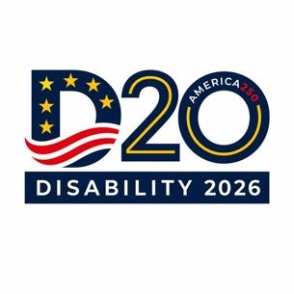
“From Commitments to Implementation: Aligning G20 Priorities with the CRPD and SDGs through Global Disability 20 (D‑20) Engagement”

Agenda:
June 11, 2026
4:45-6pm EDT

Registration: https://us02web.zoom.us/webinar/register/WN_do-nQ45pSRSS5oExbM_qoQ#/registration

- Welcome & Housekeeping (5 min) Heather Duncan World Institute on Disability
- Introduction D20 Steering Group- What is the D20 and why does it matter (7 min) Marcie Roth 2026 D20 Chair
- Keynote: “From Commitments to Implementation: Aligning G20 Priorities with the CRPD and SDGs through Global Disability 20 (D‑20) Engagement” (5 min)
Ambassador Luis Gallegos (VIDEO)
- Keynote: What Did we Learn from the G7 (5 min)
Cara Yar Khan (Waiting on a title change from Cara)
- Keynote: G20 and the Global Business Opportunity (5 min)
Katy Talikowska Valuable 500
- Panel Discussion (40 minutes)
Facilitator: Isabel Hodge 2026 D20 CoChair (5 min)
Brazil: 2024 D20 Deisiana Paes (5 min)
South Africa 2025 D20 Sikelelwa Alex Msitshana (5 min)
United States:
2026 Youth 20 (Y20): Jakeel Abdullah (5 min)
2026 Civil Society 20 (C20): Claudia Sanchez de Lozada (5 min)
2026 D20 Initial Survey Findings: Isabel Hodge & Heather Duncan (5 min)
2026 D20 Briefing/Framework/Policy: Nicole Attong & Judy Brewer (5 min)
United Kingdom: 2027 D20: Adam Hyland (5 min)
- Call to Action: 206 D20 Marcie Roth (5 min)


