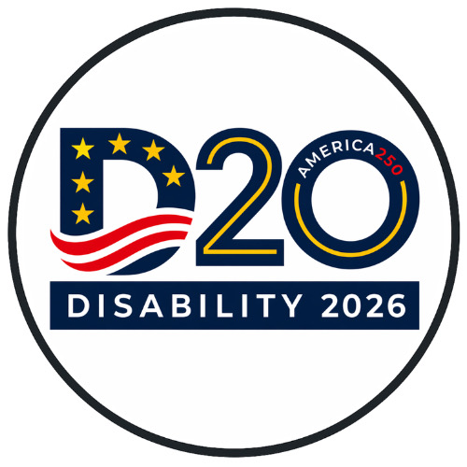

From Commitments to Implementation

Aligning G20 Priorities with the CRPD and SDGs through Global Disability 20 (D-20) Engagement
Celebrating the 20th Anniversary of the CRPD

A REMOTE ONLY SIDE EVENT AT THE 19TH CONFERENCE OF STATES PARTIES TO THE UN CONVENTION ON THE RIGHTS OF PERSONS WITH DISABILITIES

DATE
11 June 2026
Thursday

TIME
4:45 PM – 6:00 PM
Eastern Daylight Time (UTC-4) https://www.timeanddate.com/worldclock/converter.html?iso=20260611T204500&p1=179
VENUE
Remote - Zoom
──────────
Join Zoom Meeting
https://us02web.zoom.us/j/84370727936?pwd=DWmtCOLbCtQPjua0uKFxDhVecPPulO.1&jst=2
Meeting ID: 843 7072 7936 Passcode: 0303

Twenty years after adoption of the Convention on the Rights of Persons with Disabilities (CRPD), disability leaders from G20 countries are coming together to ensure that disability inclusion is not only a human rights commitment, but a driving force for economic growth, sustainable development, resilience, and global cooperation. This event will explore the role of the Disability 20 (D-20) in bringing disability-led leadership closer to global decision-making and building a permanent mechanism for engagement within the G20.
This dialogue will explore how disability-led leadership can help translate commitments under the CRPD and the Sustainable Development Goals (SDGs) into measurable action through economic participation, inclusive innovation, disaster resilience, accessibility, employment, and international cooperation.
The session will highlight lessons from Brazil's 2024 D-20, South Africa's 2025 D-20, and priorities for the United States' 2026 host year as disability leaders work together to build a lasting global platform for collaboration and influence.

FEATURED VOICES
Experts on the CRPD and SGD’s
Disability 20 (D-20) Leaders from G20 Countries including
- Representatives of the United States Disability Community
- Representatives of the 2025 South Africa D-20
- Representatives of the 2024 Brazil D-20
- Representatives of the 2027 United Kingdom D-20
Additional speakers to be announced.

CONVENED BY
World Institute on Disability (WID)
2026 Disability 20 (D-20) Steering Group
D20cochairs@wid.org
Disability Leaders from G20 Countries
with support from partners across the global disability community
Please support the D20 https://gofund.me/64a1aa9d8

